**Political Juggernauts: A Quantitative Analysis Of Candidates In The 2019 Lok Sabha Elections**

**1)INDROUCATION:**

The Lok Sabha is composed of representatives of people chosen by direct election on the basis of Universal Adult Suffrage. The Constitution of India allows for a maximum of 550 members in the House, with 530 members representing the States and 20 representing the Union Territories. The 17th Lok Sabha was formed by the members elected in the 2019 Indian general election. Elections, all across India, were conducted in seven phases from 11 April 2019 to 19 May 2019 by the Election Commission of India.

The Bharatiya Janata Party received 37.36% of the vote, the highest vote share by a political party since the 1989 general election, and won 303 seats, further increasing its substantial majority. In addition, the BJP-led National Democratic Alliance (NDA) won 353 seats.

**1.2) PURPOSE:**

Problem Understanding, also known as Problem Definition or Problem Identification, is the initial and critical phase of any data analysis or problem-solving process. It involves gaining a clear and comprehensive understanding of the problem at hand, its context, scope, and objectives.

The Requirement is to analyze the winners and total voters and electors and Postal Votes of Lok Sabha, and criminal Cases in Each State & Party.  In which State there are more winners and which party got more seats and liabilities and assets of each state. For this Created KPI’s and interactive Visualizations and Dashboard and story Board to bring clean and deep understanding of the data. Analyzing the Lok Sabha election of 2019 can provide valuable insights into various aspects of the election process and political landscape in India.

**Constituency Analysis**: Evaluate the performance of candidates in different Lok Sabha constituencies. Identify patterns and trends related to voter preferences and political affiliations in specific regions.

**2) PROBLEM STATEMENT AND DESIGN THINKING:**

The Requirement is to analyze the winners and total voters and electors and Postal Votes of Lok Sabha, and criminal Cases in Each State & Party.  In which State there are more winners and which party got more seats and liabilities and assets of each state. For this Created KPI’s and interactive Visualizations and Dashboard and story Board to bring clean and deep understanding of the data. Analyzing the Lok Sabha election of 2019 can provide valuable insights into various aspects of the election process and political landscape in India.

**Constituency Analysis**: Evaluate the performance of candidates in different Lok Sabha constituencies. Identify patterns and trends related to voter preferences and political affiliations in specific regions.

**Winning Factors:** Identify the key factors that influenced the victory of candidates in various constituencies. Analyze the impact of factors such as political party, candidate's background, campaign spending, and local issues.

**Vote Share and Swing Analysis**: Analyze the vote share of political parties in comparison to previous elections. Understand the shifts in voter preferences and swings in support for different parties.

**Election Spending Analysis**: Analyze the election spending of candidates and parties. Understand the correlation between campaign spending and election outcomes.

2.1) **EMPATHY MAP:**

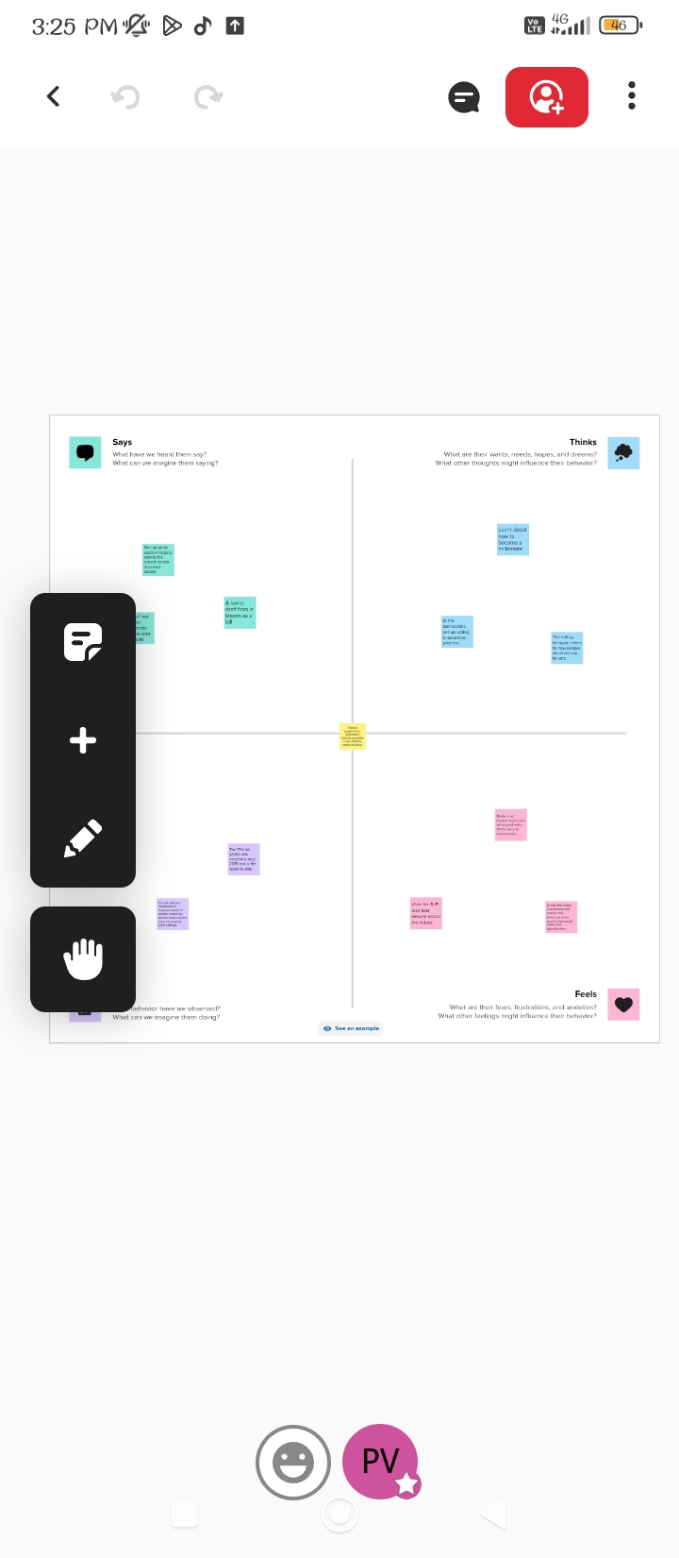

**2.2 BRAINSTROMING MAP:**

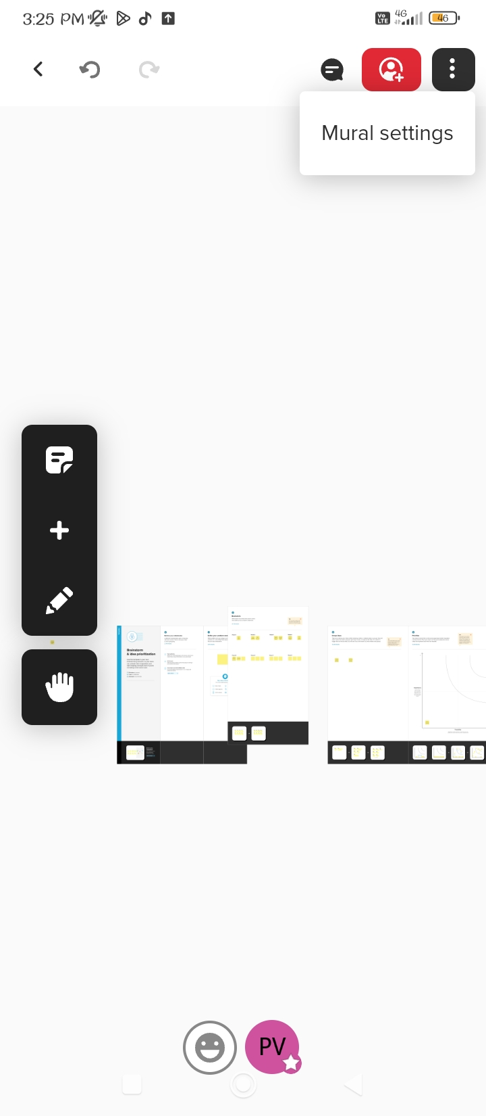

**3. RESULT:**

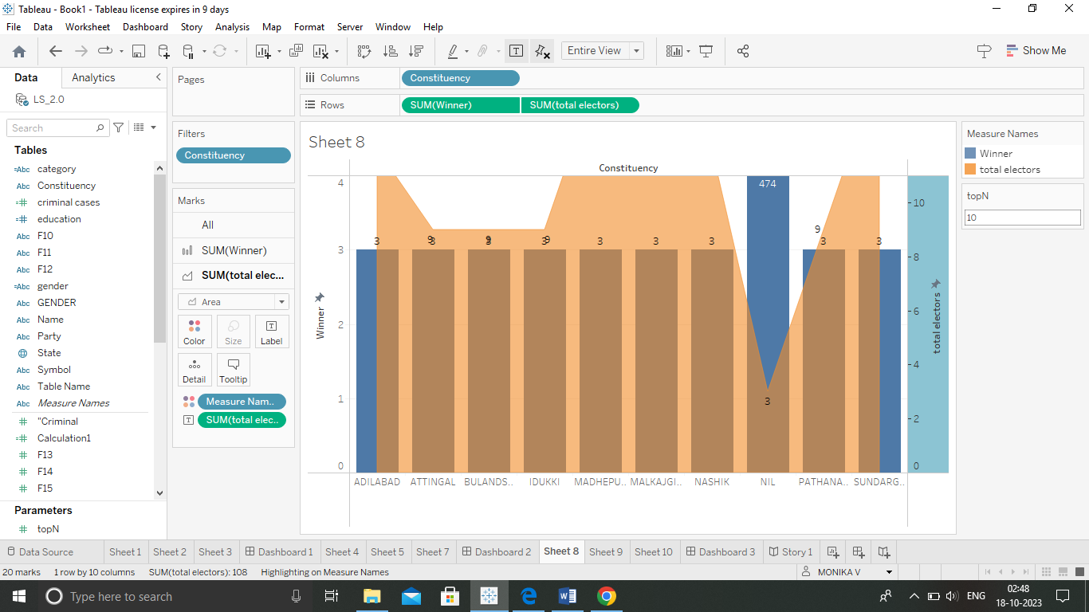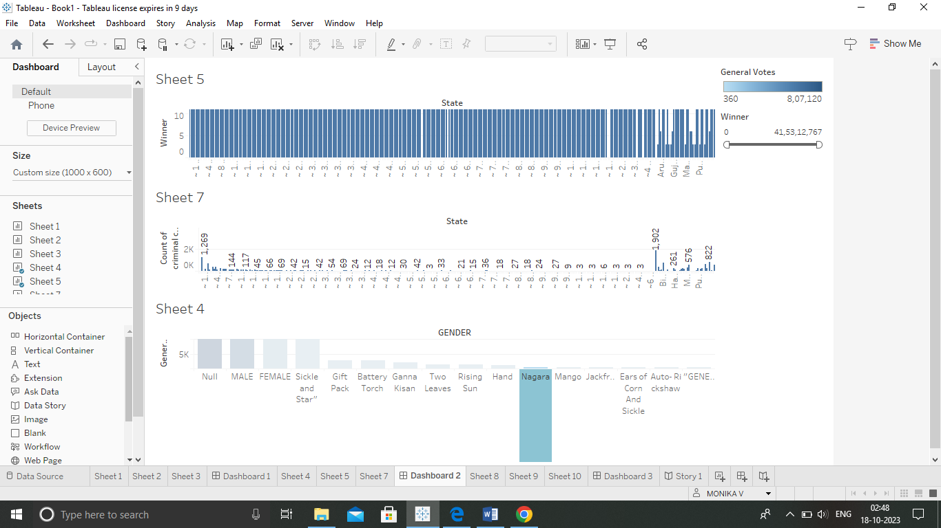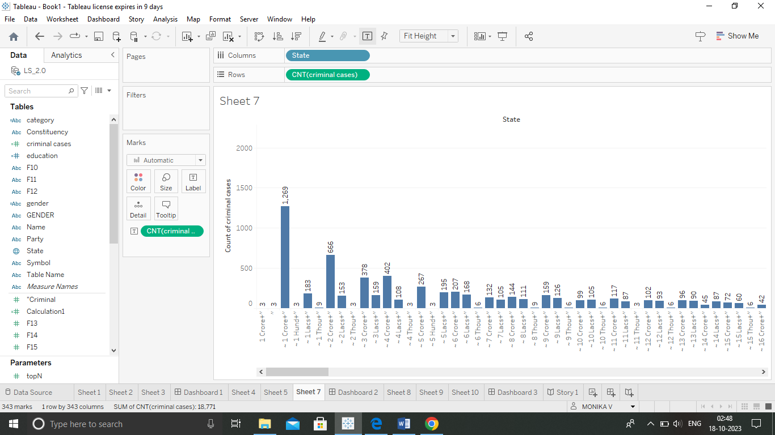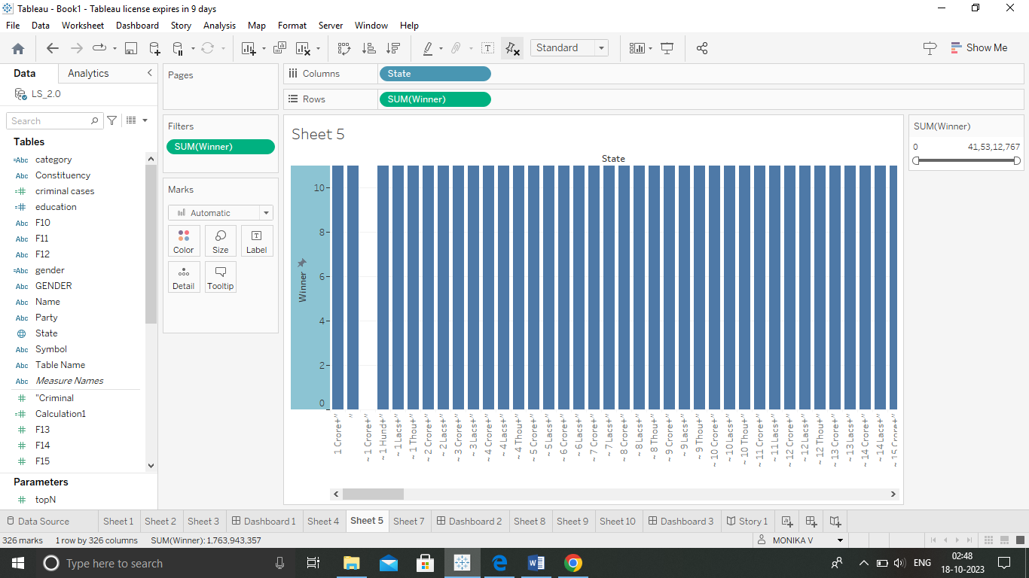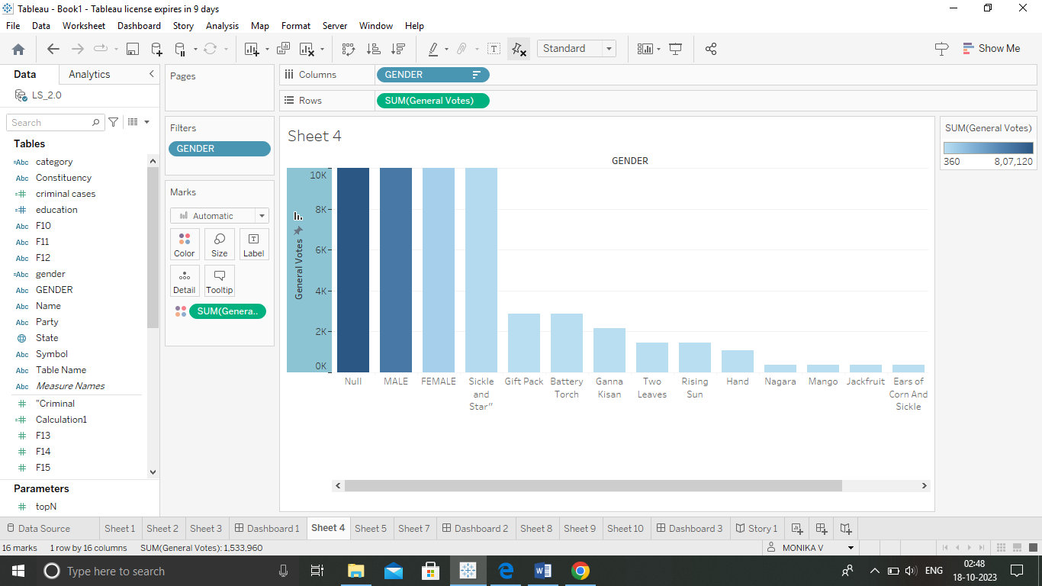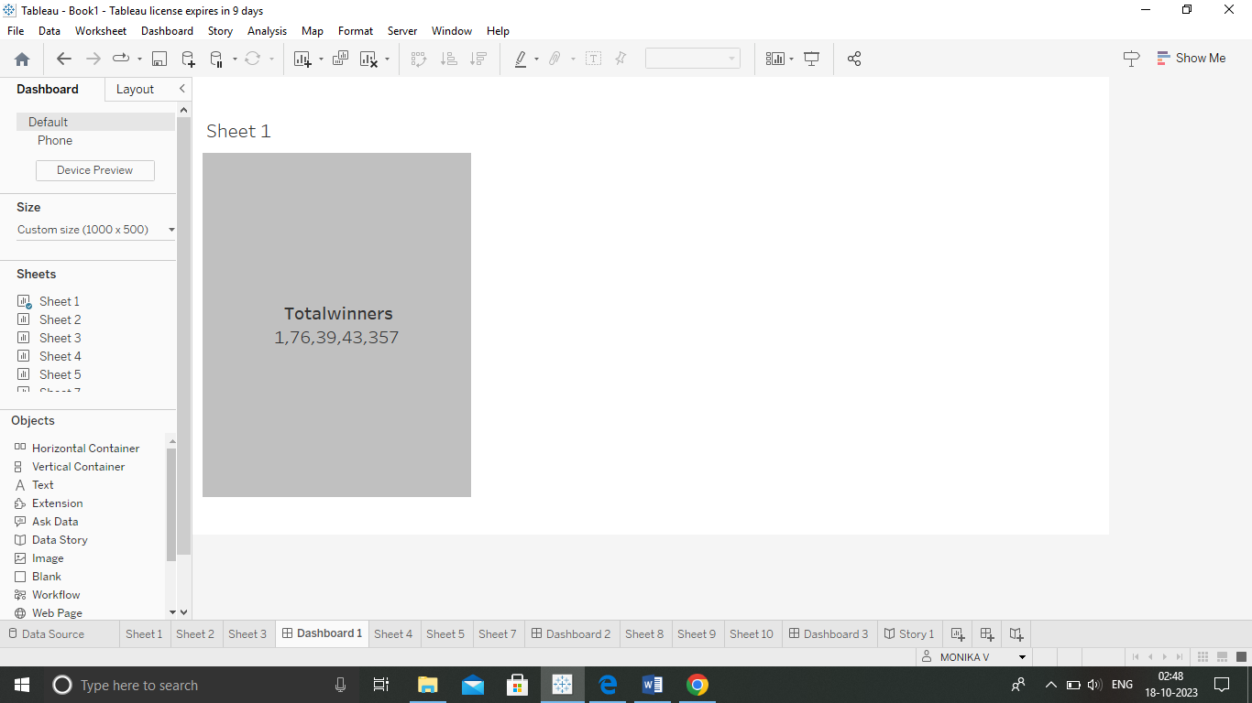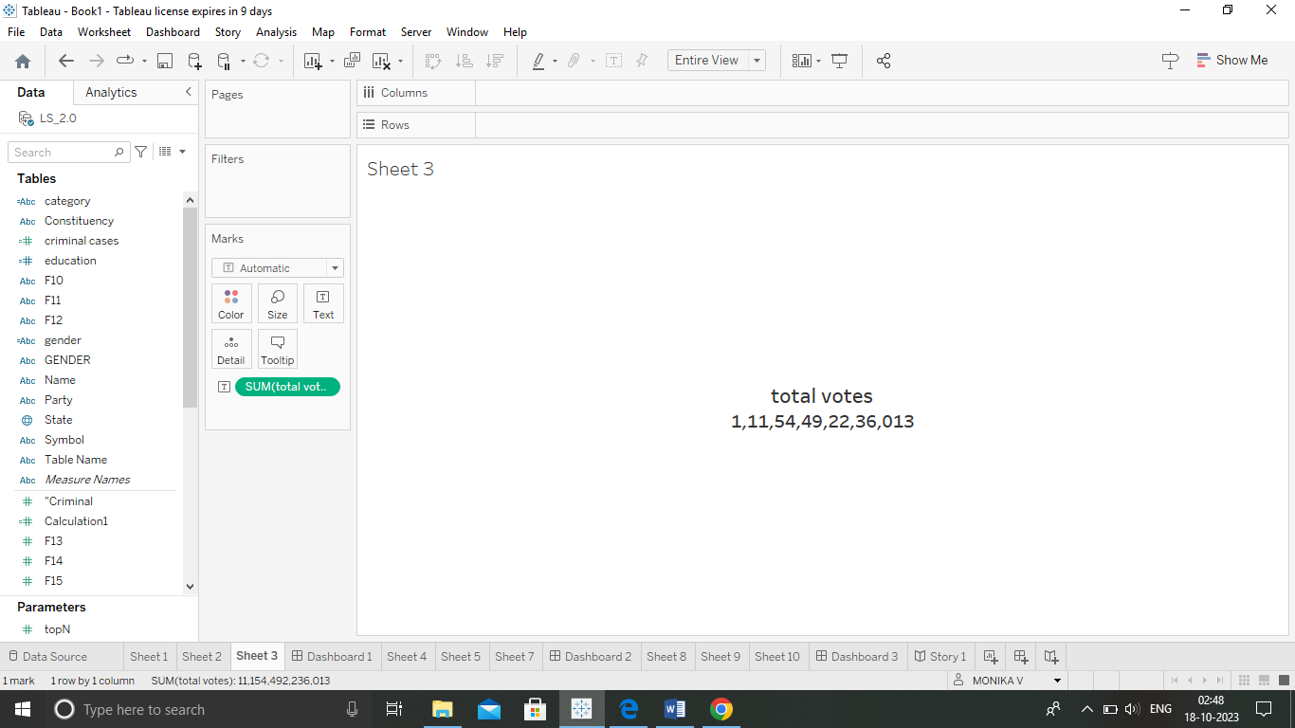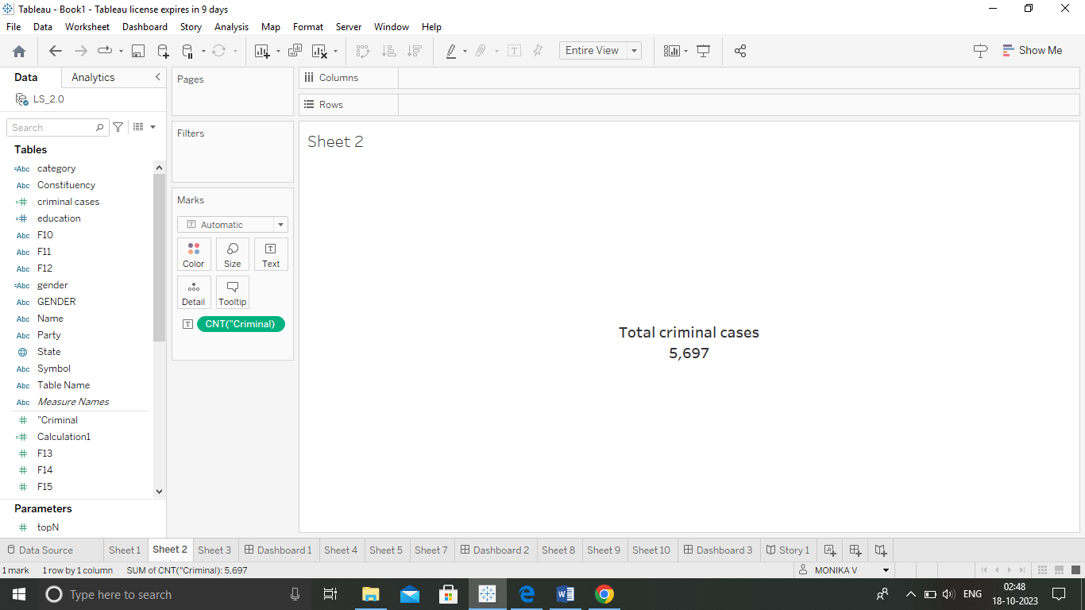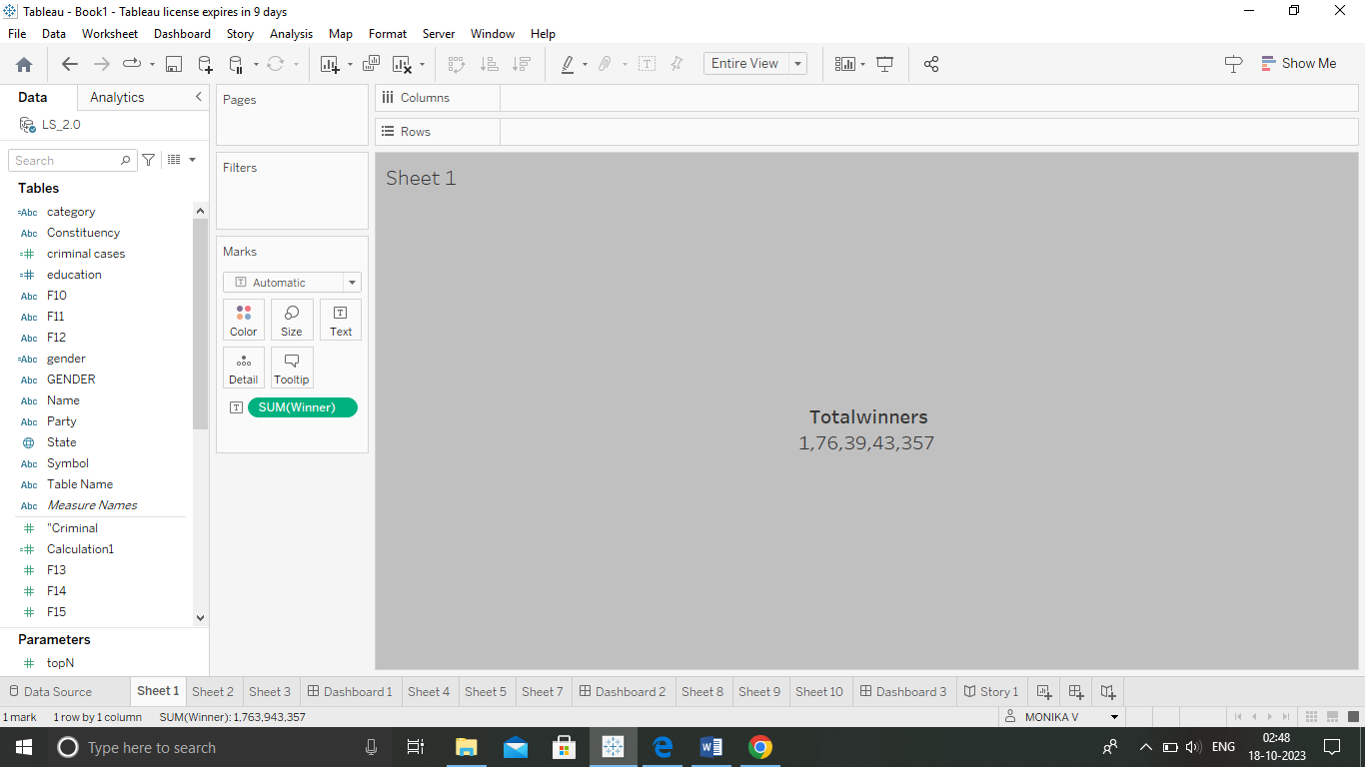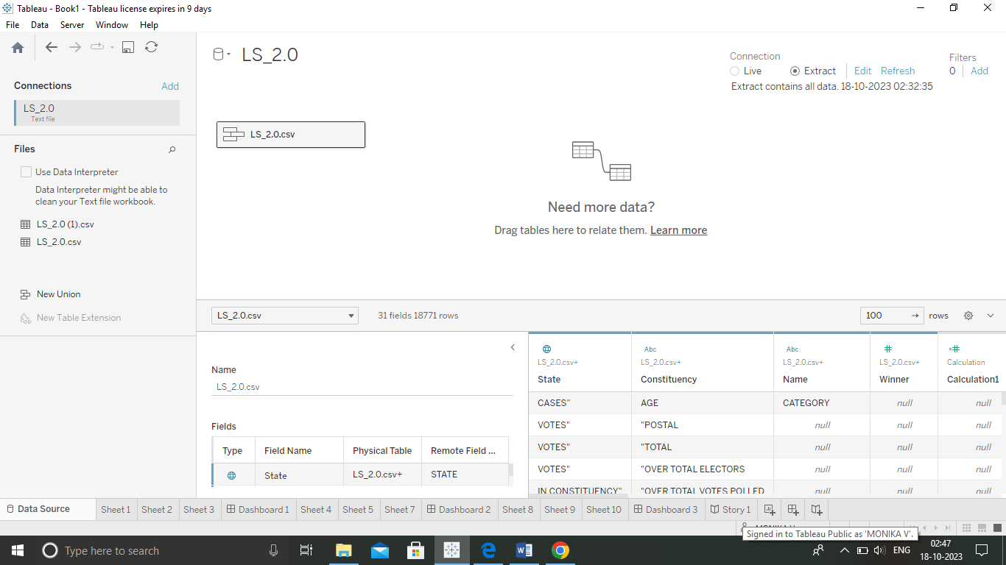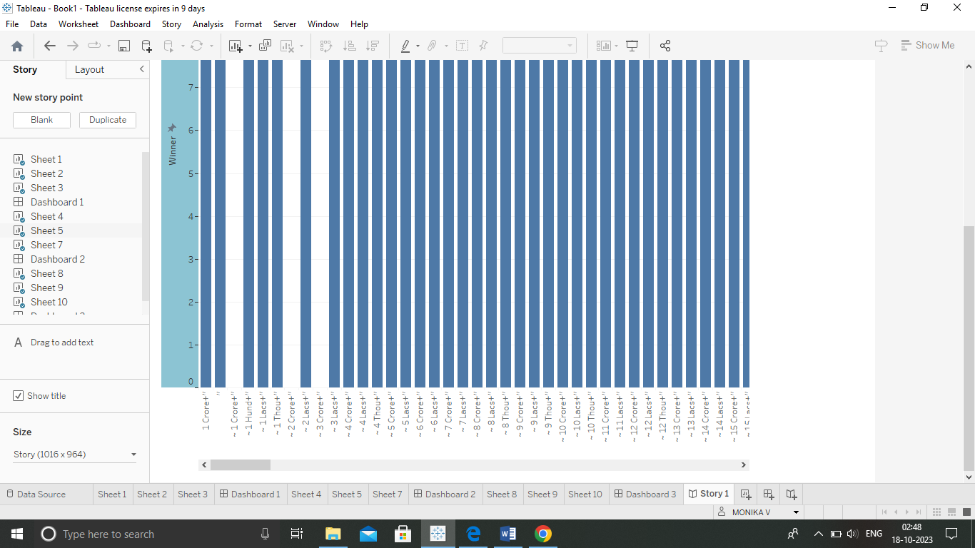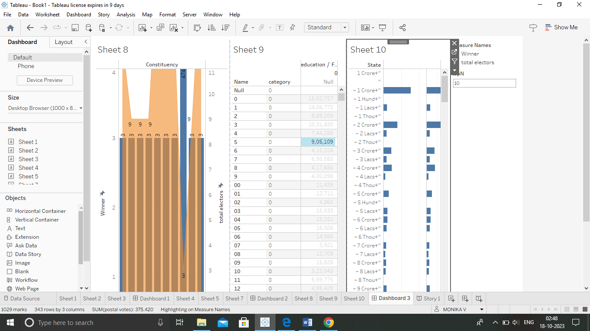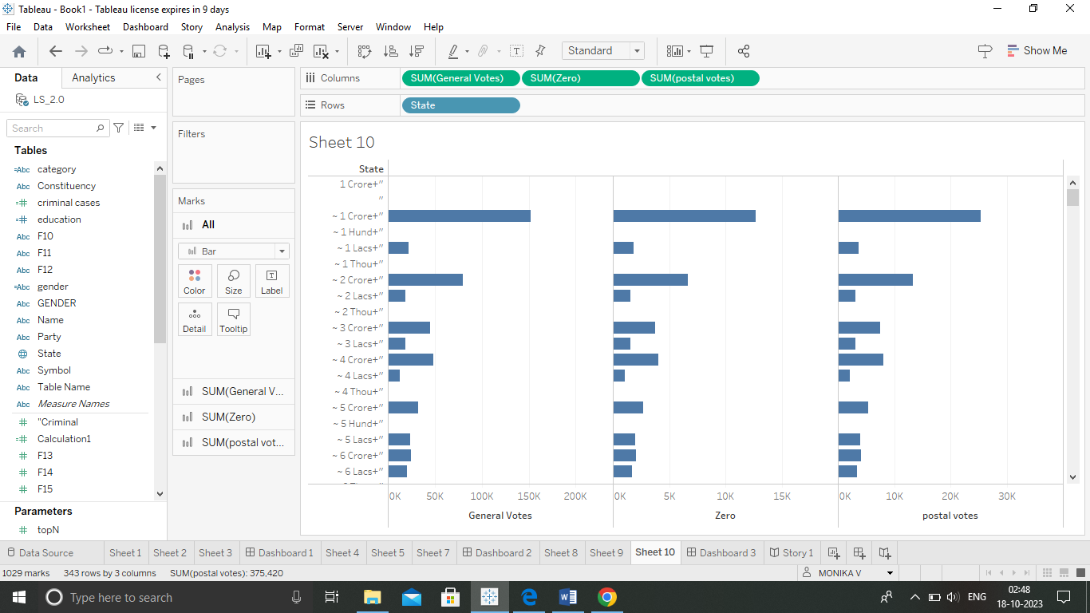

**4.)advantages and disadvantages:**

General elections were held in India in seven phases from 11 April to 19 May 2019 to elect the members of the 17th Lok Sabha. Votes were counted and the result was declared on 23 May. The election resulted in a landslide victory for the BJP which won 303 seats and formed the government.

By-elections to fifteen state assembly constituencies were held in Karnataka on 5 December 2019, and results were announced on 9 December. BJP, the ruling party, needed to win 6 out of the 15 seats to maintain its majority. It won 12 out of 15 seats.

**5.)APPLACATION:**

General elections were held in India in seven phases from 11 April to 19 May 2019 to elect the members of the 17th Lok Sabha. Votes were counted and the result was declared on 23 May. The election resulted in a landslide victory for the BJP which won 303 seats and formed the government.

The BJP's total vote share stood at 37.4 per cent, an increase of over 6 percentage points from 31.34 per cent in 2014. The National Democratic Alliance secured a vote share of 45 per cent, compared to 38 per cent in 2014. In contrast, the vote share of Indian National Congress remained the same at 19.5 per cent.

**6) CONCLUSION:**

BJP's sitting MP from Navsari CR Patil, who was seeking re-election from the seat, has registered the highest victory margin in the 2019 Lok Sabha elections. He defeated his nearest Congress rival DB Patil by a record 6.89 lakh votes.

**Shri Narendra Modi was sworn-in as India's Prime Minister on 30th May 2019, marking the start of his second term in office. The first ever Prime Minister to be born after Independence, Shri Modi has previously served as the Prime Minister of India from 2014 to 2019.**

**7.) future scope**

**In March, CPR scholars launched the Election Adda, a space for debate and analysis on key issues that have dominated this election. From forecasting and evaluating pollster perspectives to dissecting trends and debating the big themes, this series offers important insights into the 2019 campaign.**

**In the video (above), ‘Taking Stock: A Mid Poll Evaluation of the 2019 Elections’, Rahul Verma moderates a discussion between Surjit Bhalla, Sunetra Choudhury, Dhananjai Joshi and Philip K Oldenburg as part of CPR’s Election Adda series to analyse possible scenarios post May 23. The question and answer session that followed can be accessed here.**

**In the run-up to the panel above, Yamini Aiyar and Rahul Verma discussed in another episode of Election Adda whether the 2019 election was going to usher a new party system in India. Watch here – ‘Elections 2019 and the Future of the Indian Party System’. In an article in the Firstpost, Rahul Verma again analyses the evolving party system in India drawing on his book Ideology and Identity, which he co-authored with Pradeep K Chhibber.**